Automated Cloud Provisioning Portal Project Proposal
Course: CIS 675: Agile Management & Product Development
Submitted To: Dr. Tim Rodgers & Sam Ghosh
Prepared By: Edgar Ochoa, Julio Garcia, Naga Sai Deepak Chinta, Rajavel Balachandar, and Veronica McCarthy
Date: October 10, 2026

Dear Senior Management,
Please find enclosed our project proposal for the Automated Cloud Provisioning Portal at ABC Corp. We are seeking your authorization to proceed with this initiative. This proposal establishes a secure, self-service "online catalog" where software developers can instantly launch pre-approved cloud servers and testing environments in under 15 minutes, eliminating weeks of manual IT ticket queues and saving 100 operational hours every month.

Project Overview

Objective
The objective of the Automated Cloud/Infrastructure Provisioning Portal project is to design and demonstrate a secure self-service platform that enables development and engineering teams to request and provision standardized cloud environments without relying on repetitive manual IT workflows. The proposed portal will incorporate pre-approved infrastructure templates, automated security checks, cost controls, access management, and lifecycle management. The project will target an 85% reduction in infrastructure provisioning lead time and approximately 100 hours per month of reduced manual IT operational effort, subject to validation against organizational baseline data.

Business Need & Strategic Justification
ABC corp. currently struggles with speed-to-market. Speed to market is directly throttled by how quickly development teams can access infrastructure. Manual intake forms, ticketing queues, and custom configuration scripting create severe operational bottlenecks. This project bridges the gap between software development (speed) and IT operations/security (governance). It is necessary because it shifts IT Operations from a manual gatekeeper to an automated enabler, ensuring infrastructure scales cleanly while remaining secure, compliant, and cost-controlled.

Problem Statement: Friction Points & Bottlenecks
The portal addresses three core business friction points:

Prolonged Provisioning Lead Times:
Traditional ticket-based infrastructure workflows require manual handoffs between Network, Security, System Administration, and Finance teams, taking 2 to 4 weeks per environment request.

Uncontrolled Infrastructure Sprawl & Shadow IT:
Frustrated by slow delivery times, project teams frequently create unvetted public cloud accounts or leave unused environments running continuously, leading to security vulnerabilities and unnecessary or uncontrolled cloud spending.

Inconsistent Compliance & Security Postures:
Manual setup leads to configuration drift, unpatched instances, and non-compliant access control lists (ACLs), exposing the enterprise to regulatory audit failures and security breaches.

Project Description

Proposed Solution Architecture
The diagram below illustrates how internal end-users interact with the portal, which leverages Infrastructure as Code (IaC) templates and automated policy gates to deliver governed cloud environments.
Figure 1. Layered architecture of the Automated Cloud/Infrastructure Provisioning Portal.

User Stories (Requirements & Features)

US-01: Service Catalog Browsing:
As a Developer,
I want to browse a catalog of pre-approved environment blueprints (e.g., Node.js stack, Python microservice, Kubernetes namespace),
so that I can quickly select a standardized template that fits my project’s stack without designing infrastructure from scratch.

US-02: Single-Click Environment Provisioning:
As a Developer,
I want to submit a provisioning request with basic parameters (environment name, lifetime, region) and trigger automated deployment,
so that I can obtain an operational development environment in minutes without filing manual IT tickets.

US-03: Automated Cost Estimation & Approval Routing:
As a Project Lead,
I want to see an immediate estimate of monthly running costs before submitting an environment request and have requests above /month automatically routed to budget managers for approval,
so that my project stays within budget guardrails while maintaining oversight on high-cost infrastructure.

US-04: Role-Based Access Control (RBAC) Integration:
As an Enterprise Security Administrator,
I want the portal to authenticate users via enterprise Single Sign-On (SSO) and enforce Role-Based Access Control,
so that users can only view, deploy, and manage resources within their assigned team workspace and privilege boundary.

US-05: Resource Lifetime & Automated Lifecycle Management (TTL):
As a Cloud Infrastructure Manager,
I want to set default Time-To-Live (TTL) expiration limits on sandbox and test environments with automated teardown alerts,
so that abandoned environments are automatically decommissioned to eliminate wasteful cloud spending.

US-06: Automated Compliance & Security Policy Scanning:
As a Cybersecurity Specialist,
I want all catalog infrastructure templates to automatically run policy-as-code checks prior to execution, so that non-compliant configurations are blocked automatically before deployment into production or staging cloud accounts.

US-07: Centralized Resource Management Dashboard:
As an Application Owner,
I want a single dashboard showing all active environments, running costs, health status, and owner details across multi-cloud accounts, so that I have complete visibility and operational control over our active infrastructure assets.

US-08: Environment Extension Request Workflow:
As a QA Engineer,
I want to request a 7-day lifetime extension for a temporary testing environment directly from the portal interface, so that ongoing release testing is not unexpectedly interrupted by automated decommissioning policies.

US-09: Automated Secret & Credential Management:
As a Developer,
I want provisioned database and API access credentials generated, encrypted, and injected directly into our enterprise secret vault upon deployment, so that credentials are never exposed in plaintext files or stored insecurely in code repositories.

US-10: Infrastructure Health & Drift Monitoring Alerts:
As a Cloud Platform Engineer,
I want to receive real-time alerts when a deployed environment's live state strays from its defining template (configuration drift), so that I can maintain environment consistency and mitigate security risks caused by unauthorized manual changes.

US-11: Self-Service Environment Teardown:
As a Developer,
I want to manually trigger an immediate, safe destruction of a completed test environment with a single click, so that cloud billings stop immediately as soon as my testing phase finishes.

US-12: System Audit Logging & Compliance Reporting:
As an IT Compliance Auditor,
I want to export detailed audit logs recording who requested, approved, modified, and deleted infrastructure resources, so that the enterprise can maintain compliance with industry regulatory standards.

Initial Product Backlog & Prioritization
The user stories have been rank-ordered from highest to lowest priority based on business urgency, foundational dependencies, risk mitigation, and value delivery.

Prioritized User Story Ranking
Rank | User Story ID & Title | User Role | Priority Rationale Summary
1 | US-04: Role-Based Access Control (RBAC) & SSO | Security Admin | Foundational authentication and security gateway required before exposing any services.
2 | US-01: Service Catalog Browsing | Developer | Core input interface; defines what standardized infrastructure can be requested.
3 | US-02: Single-Click Environment Provisioning | Developer | Core functional delivery mechanism; fulfills the core objective of automated self-service.
4 | US-06: Automated Compliance & Security Policy Scanning | Cybersecurity Spec. | Risk gatekeeper; ensures provisioned infrastructure meets baseline security rules before execution.
5 | US-05: Resource Lifetime & Lifecycle Management (TTL) | Cloud Platform Mgr | Immediate cost control guardrail; prevents cost overruns from day one.
6 | US-03: Automated Cost Estimation & Approval Routing | Project Lead | Financial governance; ensures financial visibility before execution.
7 | US-12: System Audit Logging & Compliance Reporting | Compliance Auditor | Historical reporting and compliance validation (necessary, but secondary to active security gates).
8 | US-09: Automated Secret & Credential Management | Developer | Secure delivery; eliminates insecure credential distribution during deployments.
9 | US-07: Centralized Resource Management Dashboard | Application Owner | Post-deployment operational management and monitoring.
10 | US-11: Self-Service Environment Teardown | Developer | Operational efficiency; manual counterpart to automated TTL lifecycle management.
11 | US-08: Environment Extension Request Workflow | QA Engineer | Operational enhancement to lifecycle policies; prevents disruption of legitimate long-running tests.
12 | US-10: Infrastructure Health & Drift Monitoring Alerts | Platform Engineer | Advanced platform reliability feature; protects long-term infrastructure health after deployment pipelines mature.
Table 1: Initial Product Backlog Prioritized by Business Value and Dependency

Proposed Self-Service Infrastructure Provisioning Workflow

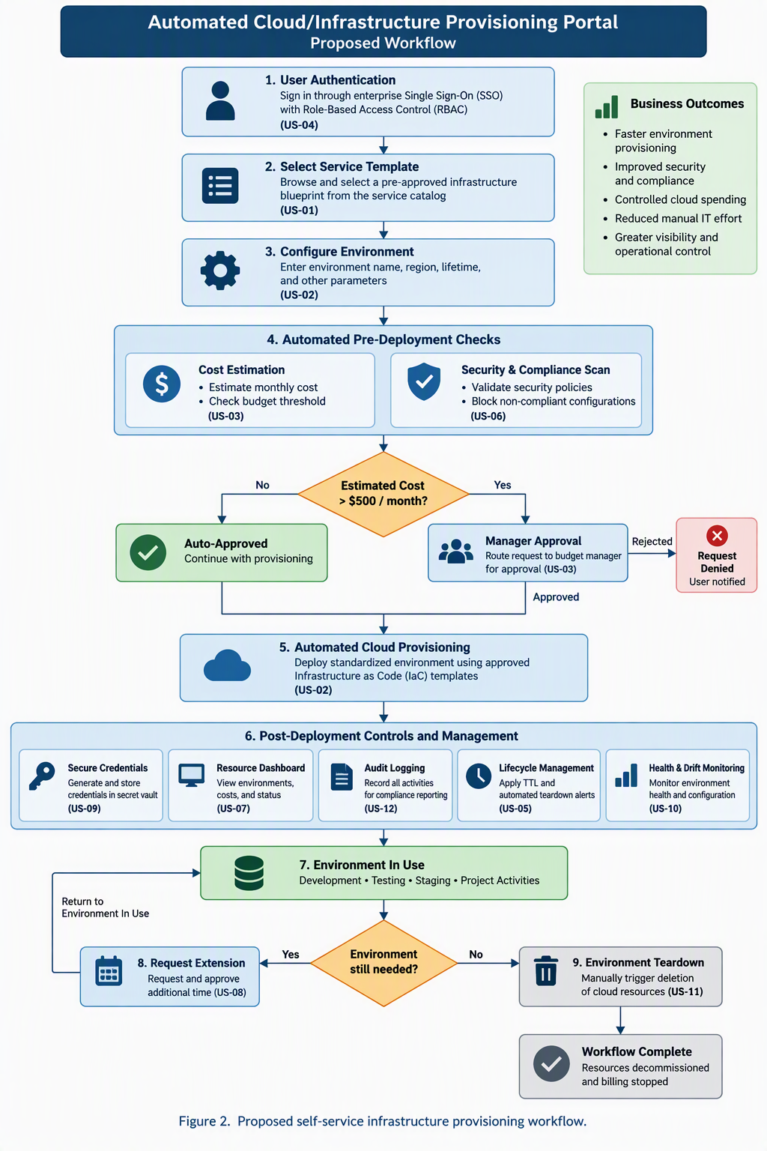
Figure 2. Proposed Self-Service Infrastructure Provisioning Workflow

Minimum Viable Product
The proposed MVP will focus on the highest-priority capabilities required to demonstrate secure self-service infrastructure provisioning. The MVP will include enterprise authentication and role-based access, an approved service catalog, automated environment provisioning, security and compliance validation, lifecycle controls, and cost estimation/approval routing. Lower-priority features will be incorporated incrementally through subsequent Agile iterations based on stakeholder feedback and business value.

Priority Justification for the Top 6 User Stories

Rank 1 - US-04 (Role-Based Access Control & SSO):
Justification: RBAC and enterprise authentication serve as the architectural foundation for the entire portal. Without identity verification and role permission management, exposing infrastructure provisioning capabilities creates compliance and security risks. Setting up security limits early prevents unauthorized users from launching unapproved resources.

Rank 2 - US-01 (Service Catalog Browsing):
Justification: Before infrastructure can be deployed automatically, developers must have a structured, pre-approved catalog to select from. This feature establishes the standardized template library (Infrastructure as Code) that enforces organizational best practices and eliminates manual configuration errors.

Rank 3 - US-02 (Single-Click Environment Provisioning):
Justification: This feature directly solves the primary business problem: reducing provisioning lead times from weeks to minutes. Combining the catalog selection (US-01) with automated provisioning engines (US-02) completes the Minimum Viable Product (MVP) core engine, yielding immediate, measurable ROI.

Rank 4 - US-06 (Automated Compliance & Security Policy Scanning):
Justification: In an enterprise environment, rapid automated deployment cannot compromise security. Implementing security-as-code guardrails early ensures that every automatically deployed template adheres to security benchmarks, eliminating human error and preventing security vulnerabilities from reaching live environments.

Rank 5 - US-05 (Resource Lifetime & Lifecycle Management - TTL):
Justification: Uncontrolled cloud cost accumulation from orphaned, forgotten test environments is a primary driver for building this portal. Implementing automatic Time-To-Live policies at launch guarantees immediate cost guardrails and prevents wasteful cloud spending as adoption scales.

Rank 6 - US-03 (Automated Cost Estimation & Approval Routing):
Justification: Financial governance is critical for business adoption. Showing developers real-time cost estimates before deployment encourages cost-conscious decisions, while automated approval routing for high-cost infrastructure ensures budget oversight without delaying low-cost, routine development environments.

Conclusion and Request for Approval
The Automated Cloud/Infrastructure Provisioning Portal addresses a clear operational challenge by replacing repetitive, manual infrastructure requests with a governed self-service process. The proposed solution seeks to improve delivery speed without sacrificing security, financial oversight, or operational control. Using an Agile approach will allow the team to deliver high-value capabilities first, validate the solution with stakeholders, and incorporate feedback through subsequent iterations. The project team therefore requests approval to proceed with development of the proposed MVP and refinement of the initial product backlog.

AI Declaration:
Gemini (AI), NotebookLM, and Claude were used for idea generation and detailed content creation. The project team conducted brainstorming, refined operational requirements, and added key details to the project description.

